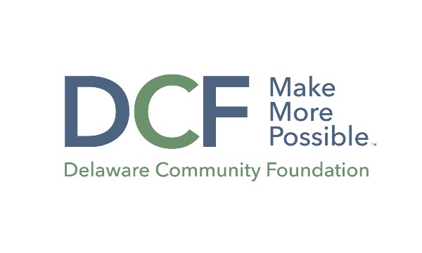

Guidelines for the Specific Interest Grants at the Delaware Community Foundation.

There are a variety of funds at the DCF that provide a structured opportunity for eligible nonprofits whose missions align with specific interest areas to apply for grants. These specific areas include:

Dave Ryerson Fund and the Beekhuis Community Fund: Statewide small arts grants programs and projects.

These small grants will support the arts throughout Delaware. The opportunity is designed for small organizations or larger organizations with smaller, discrete projects. Supported programs include the presentation of performing, visual, literary, media or folk arts in communities throughout Delaware, and that reach audiences and participants with limited access to the arts or to a particular art form.
Awards will range from $1,000 to 2,500.
Quintin E. Primo Jr. Fund for Racial Justice and the African American Empowerment Fund of Delaware: Educational programs and projects that promote racial justice and the empowerment of African Americans.
These small grants will support educational programs and projects that promote racial justice and the empowerment of African Americans.
Awards will range from $1,000 to 2,500.
21st Century Children’s Fund: Education programming or Financial assistance programs for at-risk children or young adults up to age 21 to participate in programs or experiences that help them define their strengths, improve their self-esteem, and build a sense of hope for the future.

These small grants will fund education programming or financial assistance programs for at-risk children or young adults up to age 21 to participate in programs or experiences that help them define their strengths, improve their self-esteem, and build a sense of hope for the future.

Awards will range from $2,500 to $5,000

June J. and Russell W. Peterson Fund: To support programs submitted by Delaware organizations that serve the poor through one or more of the following fields: jobs, housing, health care, education, and community members re-entering society.

Awards will range from $1,000 to $1,500

