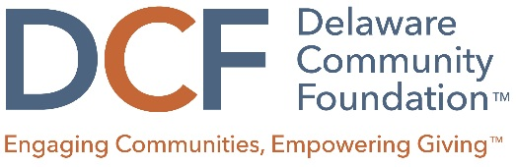

Wilmington | Georgetown | delcf.org

Building Opportunity in Delaware 2022 Book Circle Discussions

As you discuss I Never Thought Of It That Way: How To Have Fearlessly Curious Conversations in Dangerously Divided Times, by Mónica Guzmán, here are a few suggested questions that might help stimulate conversation.
- What was your initial reaction to the book?

- Do you agree that we are dangerously divided as a country? Why or why not? Do you see this in Delaware too?

- Does the “SOS” concept – sorting, othering, and siloing – resonate with you? What are examples of this you have experienced?

- What’s one thing you can do this week to be more curious?

- Has reading I Never Thought of it That Way changed the way you think about bridging divides and civil discourse? How could a healthier civil society advance equity and opportunity?

- Has reading I Never Thought of it That Way changed your perception of your community or of Delaware? Has it changed your opinion or perspective about anything else?

- What INTOIT (I Never Thought Of It That Way) moments did you have while reading the book?

We would love your feedback about your Book Circle discussion. Please share your thoughts and ideas here: (https://www.surveymonkey.com/r/DW938WD). Thank you!
